Sharyland North Jr. High
Girls Basketball Schedule
2018-2019
7th Grade White & Red

Nov. 2 B.L. Gray Away 5:30/6:30

Nov. 3 8th Red Tournament
8th White Tournament

Nov. 9 Valley View Home 5:30/6:30

Nov. 10 8th Red Tournament
8th White Tournament

Nov. 12 MJH Home 5:30/6:30

Nov. 26 BL Gray Away 5:30/6:30

Dec. 3 Cantu Home 5:30/6:30

Dec. 10 Alton Away 5:30/6:30

Dec. 17 K-White Away 5:30/6:30

Coaching Staff Administrators
Elida Galvan- 8th Grade Red Lorene Bazan- Principal
Nora Saucedo- 8th Grade White Hector Limas – Asst. Principal
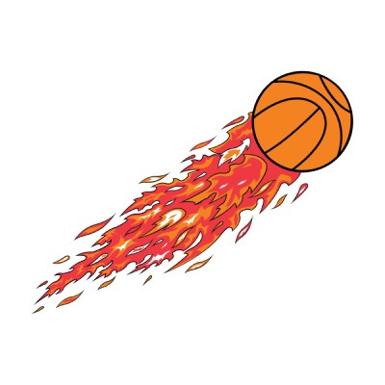
Ricky Woods- 7th Grade Red Raquel Adame-Asst. Principal
Practice Hard
Play Strong
Love the Game
NORTH BASKETBALL
Cynthia Villegas- 7th Grade White Richard Thompson-Athletic Director

