Sharyland North Jr. High
Girls Basketball Schedule
2018-2019
8th Grade White & Red

Nov. 2 B.L. Gray Home 5:30/6:30

Nov. 3 8th Red Tournament
8th White Tournament

Nov. 9 Valley View Away 5:30/6:30

Nov. 10 8th Red Tournament
8th White Tournament

Nov. 12 MJH Away 5:30/6:30

Nov. 26 BL Gray Home 5:30/6:30

Dec. 3 Cantu Away 5:30/6:30

Dec. 10 Alton Home 5:30/6:30

Dec. 17 K-White Home 5:30/6:30

Coaching Staff Administrators
Elida Galvan- 8th Grade Red Lorene Bazan- Principal
Nora Saucedo- 8th Grade White Hector Limas – Asst. Principal
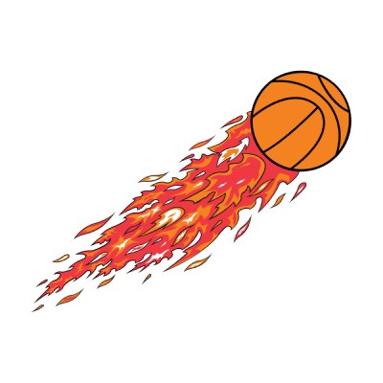
Marina Aguilar- 7th Grade Red Raquel Adame-Asst. Principal
Practice Hard
Play Strong
Love the Game
NORTH BASKETBALL
Cynthia Villegas- 7th Grade White Richard Thompson-Athletic Director

